National Taiwan Normal University

Simultaneous Localization and Mapping

Final Project
Modified Gymnasium Taxi Driver: Problem Solved with Q-Learning Algorithm

KEVIN 常凱文
11109356A

23 December 2025

Lecturer
Distinguished Assistant Professor Saeed Saeedvand

- INTRODUCTION
Taxi-V3 is an environment provided by Gymnasium that can be found here: https://gymnasium.farama.org/environments/toy_text/tax. The Taxi problem involves navigating to passengers in a grid world, picking them up, and dropping them off. In this section, the original environment has been modified to meet the final project requirement due to the professor’s need. The modification consist new observation state called danger zone, and another new passenger.
This problem has been solved with Q-Learning and in this report we will discuss how I solve the problem.

- IMPLEMENTATION
- New Environment
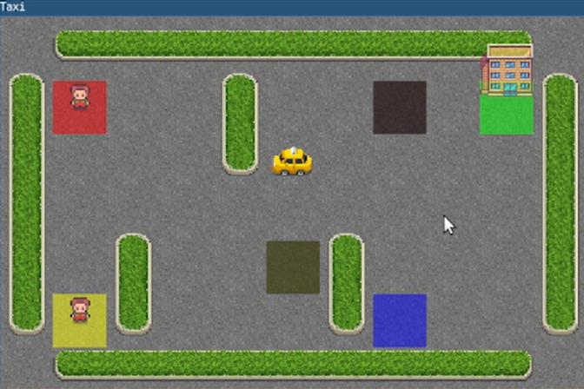
Read this documentation to learn more information about how we define our own environment https://gymnasium.farama.org/introduction/create_custom_env/ although here I’m not exactly building an environment from scratch, but instead I just copied and pasted the original environment from the installed library and then made modifications. register(
id="MyTaxi-v3",
entry_point="my_taxi:MyTaxiEnv",
max_episode_steps=200,
)
It can be done using a simple line of code; I just need to change the class name and file name to distinguish the original and my version. After that

